COS20019

Cloud Computing Architechture

Truong Ngoc Gia Hieu

105565520

Week 8 – ACA Module 11:

Guided Lab: Automating Infrastructure with AWS CloudFormation

**Guided Lab: Automating Infrastructure Deployment with AWS CloudFormation**

**A. Lab Overview and objectives**

Deploying infrastructure in a consistent, reliable manner is difficult. It requires people to follow documented procedures without taking any undocumented shortcuts. It can also be difficult to deploy infrastructure after hours when fewer staff are available. AWS CloudFormation changes this situation by defining infrastructure in a template that can be automatically deployed—even on an automated schedule.

In this lab, you learn how to deploy multiple layers of infrastructure with AWS CloudFormation, update a CloudFormation stack, and delete a stack (while retaining some resources).

After completing this lab, you should be able to do the following:

* Use AWS CloudFormation to deploy a virtual private cloud (VPC) networking layer.
* Use AWS CloudFormation to deploy an application layer that references the networking layer.
* Explore templates with AWS CloudFormation Designer.
* Delete a stack that has a deletion policy.

**Duration**

This lab will require approximately **20 minutes** to complete.

**AWS service restrictions**

In this lab environment, access to AWS services and service actions might be restricted to the ones that are needed to complete the lab instructions. You might encounter errors if you attempt to access other services or perform actions beyond the ones that are described in this lab.

**B. Accessing the AWS Management Console**

To access the AWS Management Console, click on the button **Start Lab** and wait the circle next to the AWS text **turns from yellow to green**

***Figure 1: AWS Management activated***

**C. Task 1: Deploying a networking layer**

It's a best practice to deploy infrastructure in *layers*. Common layers include the following:

* Network (Amazon Virtual Private Cloud)
* Database
* Application

This way, templates can be reused between systems. For example, you can deploy a common network topology between development, test, and production environments, or deploy a standard database for multiple applications.

In this task, you deploy an AWS CloudFormation template that creates a networking layer by using Amazon VPC.

***Step 1.1*:** Download the material named[**lab-network.yaml**](https://aws-tc-largeobjects.s3.us-west-2.amazonaws.com/CUR-TF-200-ACACAD-3-113230/14-lab-mod11-guided-CFn/s3/scripts/lab-network.yaml)

***Step 1.2:*** Search and select **CloudFormation** service. Then, Choose **Create stack > With new resources (standard)**

***Figure 2: CloudFormation homepage***

***Step 1.3:*** Configure following settings in **Step 1: Create stack**

* **Prepare template:** Choose  Template is ready.
* **Template source**: Choose Upload a template file > Choose file, and then choose the lab-network.yaml file that you downloaded.
* Choose **Next.**

***Figure 3: Create stack confirmation***

***Step 1.4:*** Configure **Step 2: Specify stack details**

* **Stack name**: lab-network
* A blue line on a white background

  AI-generated content may be incorrect.Choose **Next**.

***Figure 4: Specify task details confirmation***

***Step 1.5:*** Configure **Step 3: Configure stack options**

* In the **Tags** section, choose **Add new tag** and configure the following:
  + **Key**: application
  + **Value**: inventory
* A screenshot of a computer

  AI-generated content may be incorrect.Choose **Next.**

***Figure 5: Tag confirmation***

***Step 1.6:*** Review and click **Submit** button

***Figure 6:*** A screenshot of a computer

AI-generated content may be incorrect.***Submit successfully***

***Step 1.7:*** Choose the **Stack info** tab and check the Status to change to CREATE_COMPLETE.

***Figure 7: Stack info tab***

***Step 1.8:*** Choose the **Resources** tab.

***Figure 8: Resources tab***

***Step 1.9:*** Choose the **Outputs** tab.

***Figure 9: Outputs tab***

***Step 1.10:*** Choose the **Template** tab.

***Figure 10: Template tab***

**D. Task 2: Deploying an application layer**

Now that you deployed the *network layer*, you will deploy an *application layer* that contains an Amazon Elastic Compute Cloud (Amazon EC2) instance and a security group.

The AWS CloudFormation template *imports* the VPC and subnet IDs from the *outputs* of the existing CloudFormation stack. Then, it uses this information to create the security group in the VPC and the EC2 instance in the subnet.

***Step 2.1:*** Download the material [lab-application.yaml](https://aws-tc-largeobjects.s3.us-west-2.amazonaws.com/CUR-TF-200-ACACAD-3-113230/14-lab-mod11-guided-CFn/s3/scripts/lab-application.yaml)

***Step 2.2:*** In the CloudFormation homepage, choose **Stacks**, select **Create stack** button, and choose **Create stack > With new resources (standard)**

***Step 2.3:*** In **Step 1: Create Stack**, configure:

* **Prepare template**: Choose  **Template is ready**.
* **Template source**: Choose **Upload a template file > Choose file**, and then choose the **lab-application.yaml** file that you downloaded.
* Choose **Next**.

***Figure 11: Create stack configuration***

***Step 2.4:*** Configure following settings in **Step 2: Specify stack details**

* **Stack name**: lab-application
* Notice the NetworkStackName: lab-network
* 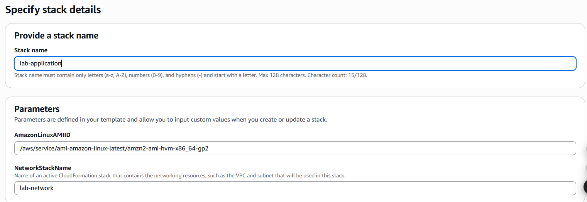Choose **Next**.

***Figure 12: Specify task configuration***

***Step 2.5:* Step 3: Configure stack options**

* In the **Tags** section, choose **Add new tag** and configure the following:
* Key: application
* **Value:** inventory
* A close-up of a computer screen

  AI-generated content may be incorrect.Choose **Next.**

***Figure 13: Tags configuration***

***Step 2.6:*** Check all configurations are correct and then press **Submit** button

***Figure 1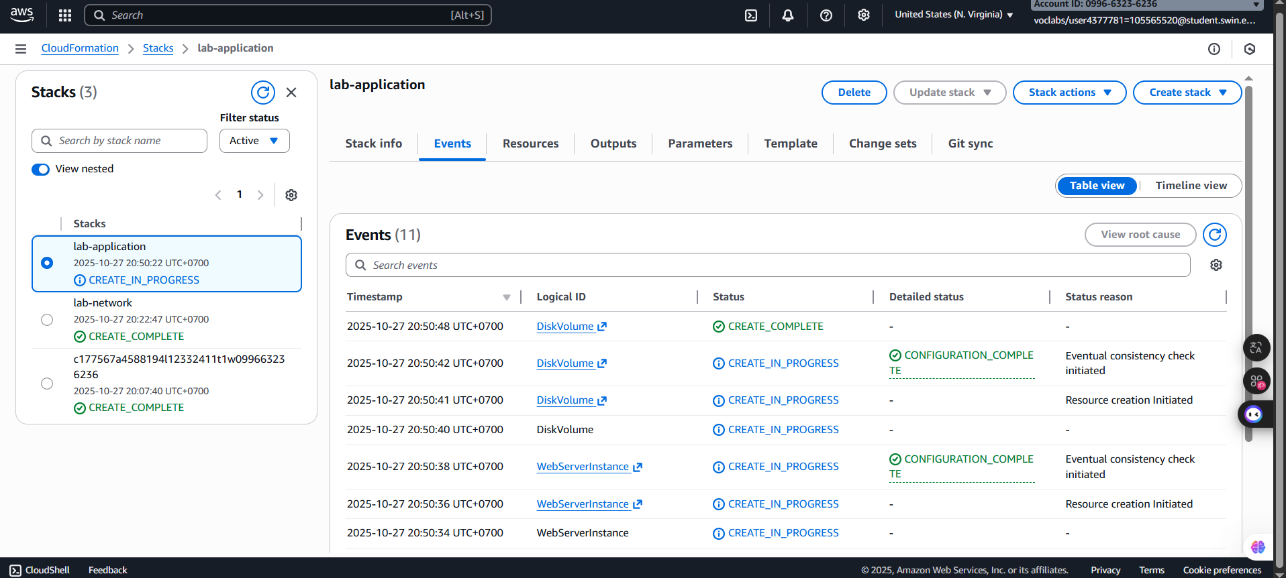4: Submit successfully***

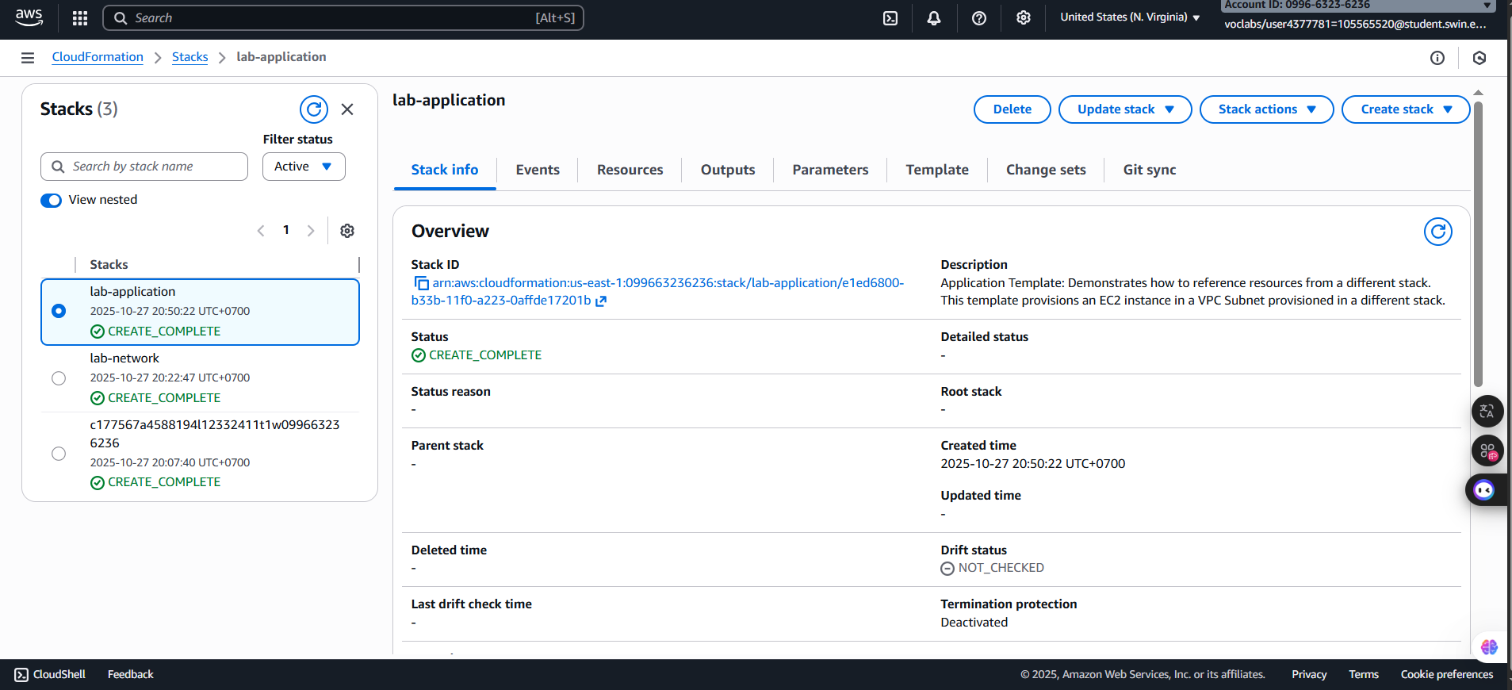***Step 2.7:*** In the Stack info tab, wait for the **Status** to change to CREATE_COMPLETE.

***Figure 15: Status checks***

***Step 2.8: Choose the Outputs tab.***

***Figure 16: Outputs tab***

***Step 2.9***: Copy the **URL** that is displayed, open a new web browser tab, paste the URL, and press ENTER

***Figure 17: Link result***

**E. Task 3: Updating a Stack**

AWS CloudFormation can also *update* a stack that was deployed. When you update a stack, AWS CloudFormation will only modify or replace the resources that are being changed. Any resources that are not being changed will be left as-is.

In this task, you update the lab-application stack to modify a setting in the security group.

***Step 3.1:*** At the top of the AWS Management Console, in the search box, search for and choose **EC2**. In the left navigation pane, in the Network & Security section, choose **Security Groups**.

***Figure 18: Security Groups page***

***Step 3.2:*** Select the check box for **lab-application-WebServerSecurityGroup**. Next, Choose the **Inbound rules** tab.

Currently, only one rule is in the security group. The rule permits *HTTP* traffic.

***Figure 20: Inbound rules tab***

***Step 3.3:*** From the **Services** menu at the top, choose **CloudFormatio**n. From the Stacks list of the AWS CloudFormation console, choose **lab-application**.

***Figure 21: lab-application selected***

***Step 3.4:*** Choose **Update stack => Create change set** and configure:

* Prepare template: Choose Replace current template.
* Template source: Choose Upload a template file.
* A screenshot of a computer

  AI-generated content may be incorrect.Upload a template file: **Choose file**, and then choose the **lab-application2.yaml** file that you downloaded.

***Figure 22: Step 1 configuration***

***Step 3.5:*** Choose **Next** on each of the next three screens to go to the Review lab-application page. In the next step, Choose **Submit**.

***Figure 23: Changed successfully***

***Step 3.6:*** In the **Stack** info tab, wait for the Status to change to UPDATE_COMPLETE.

***Figure 24: Status check***

***Step 3.7:*** Return to the **EC2** and choose **Security Groups** to check the inbound rules of the **lab-application-WebServerSecurityGroup.**

***Figure 25: Inbound rules check***

**F. Task 4: Exploring templates with AWS CloudFormation Designer**

AWS CloudFormation Designer (Designer) is a graphic tool for creating, viewing, and modifying AWS CloudFormation templates. With Designer, you can diagram your template resources by using a drag-and-drop interface, and then edit their details through the integrated JSON and YAML editor.

Whether you are a new to AWS CloudFormation or an experienced AWS CloudFormation user, Designer can help you quickly see the interrelationship between a template's resources. It also enables you to easily modify templates

***Step 4.1:*** From the Services menu, choose **CloudFormation*.***

***Figure 26: CloudFormation homepage***

**G. Task 5: Deleting the stack**

***Step 5.1:*** Return to the main **AWS CloudFormation** console, In the list of **stacks,** choose the **lab-application link** and choose **Delete**.

***Figure 27: Delete announcement***

***Step 5.2:*** Choose **Delete*.***

***Figure 28: Delete successfully***

***Step 5.3:*** From the Services menu, choose EC2. In the left navigation pane, in the Elastic Block Store section, choose **Snapshots.**

You see a snapshot **Web Data** with a **Started** time in the last few minutes, and it changes to **Completed** soon.

***Figure 29: Snapshots page***

**G. Submitting work**  
  
  
  
  
  
  
  
  
  
  
  
  
  
  
  
  
  
  
  
  
  
  
  
  
  
  
  
  
  
  
  
  
  
  
  
  
  
  
  
  
  
  
  
***Figure 30: Completed work***

**H. Conclusions**

I successfully completed this guided lab, demonstrating proficiency in automating infrastructure using AWS CloudFormation. I deployed the environment in layers, first creating the networking stack (lab-network) , and then the application stack (lab-application) which referenced the network outputs. I then practiced updating the application stack to modify the Security Group and add an HTTPS ingress rule. Finally, I verified the concept of deletion policies by observing that a snapshot of the application data was retained after I deleted the lab-application stack. This hands-on exercise confirmed my ability to use Infrastructure as Code for reliable deployment, updating, and layered resource management